Monsieur Adama JEMAA claude.ai

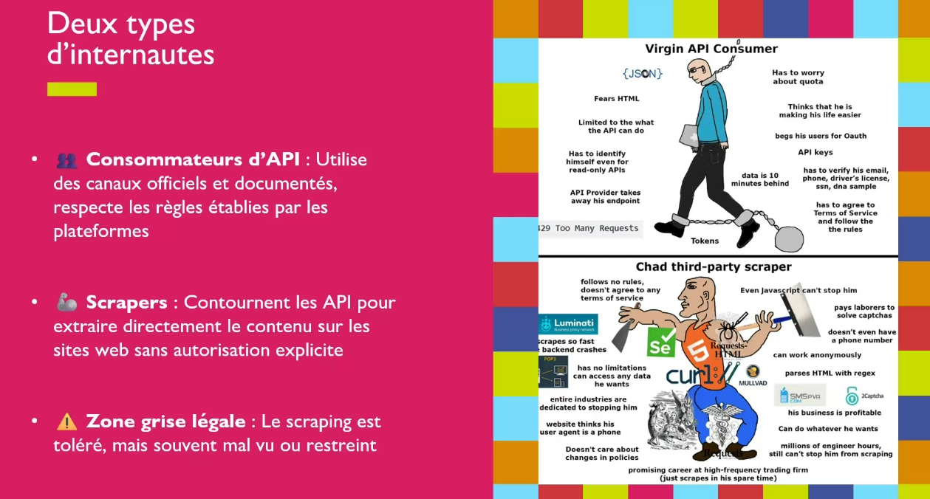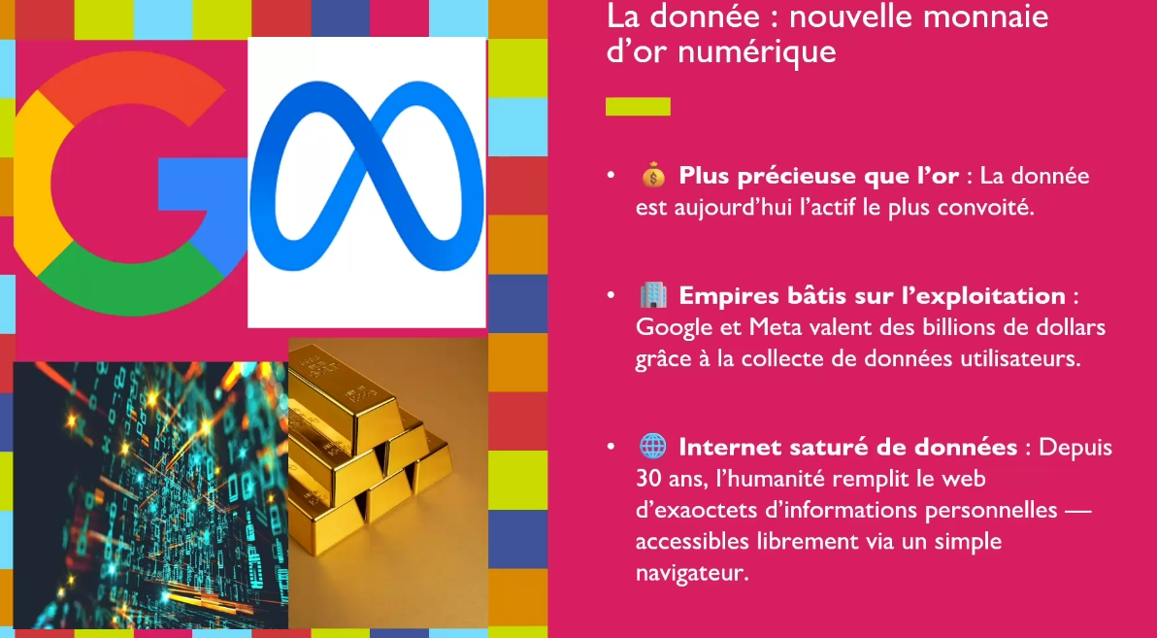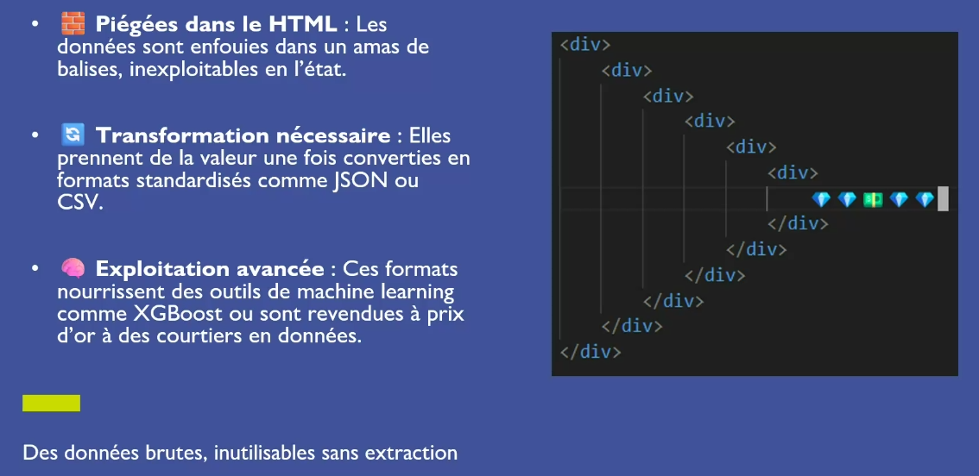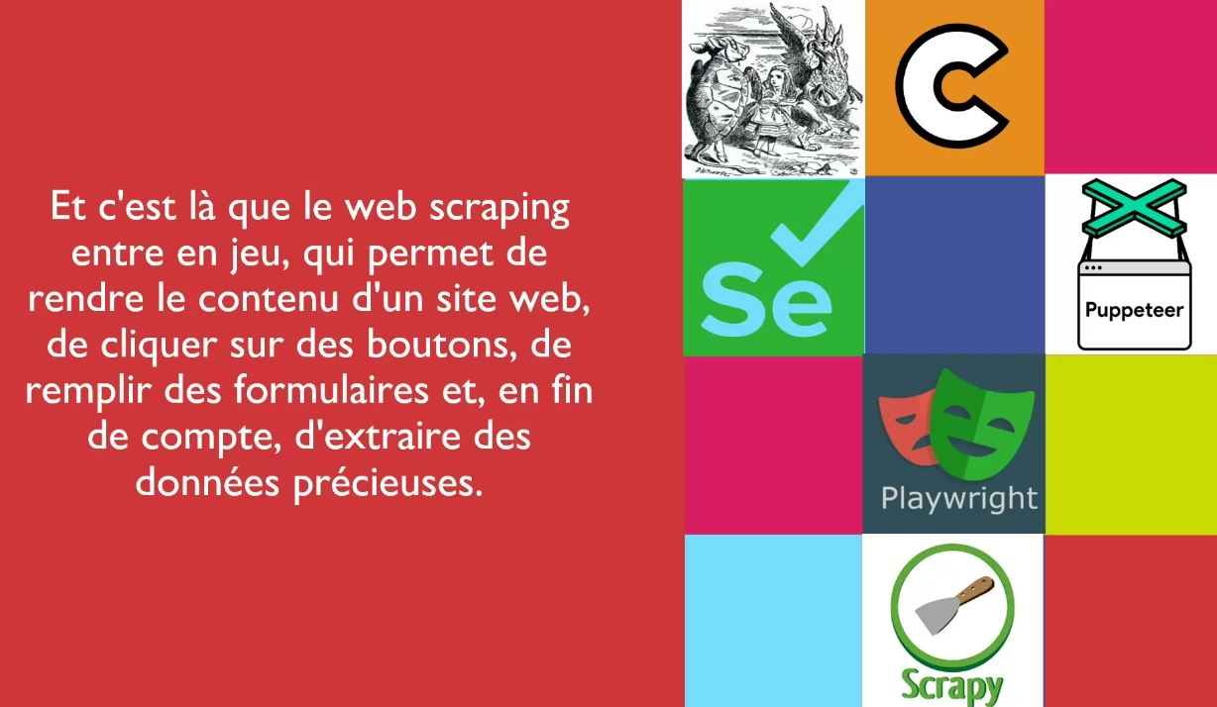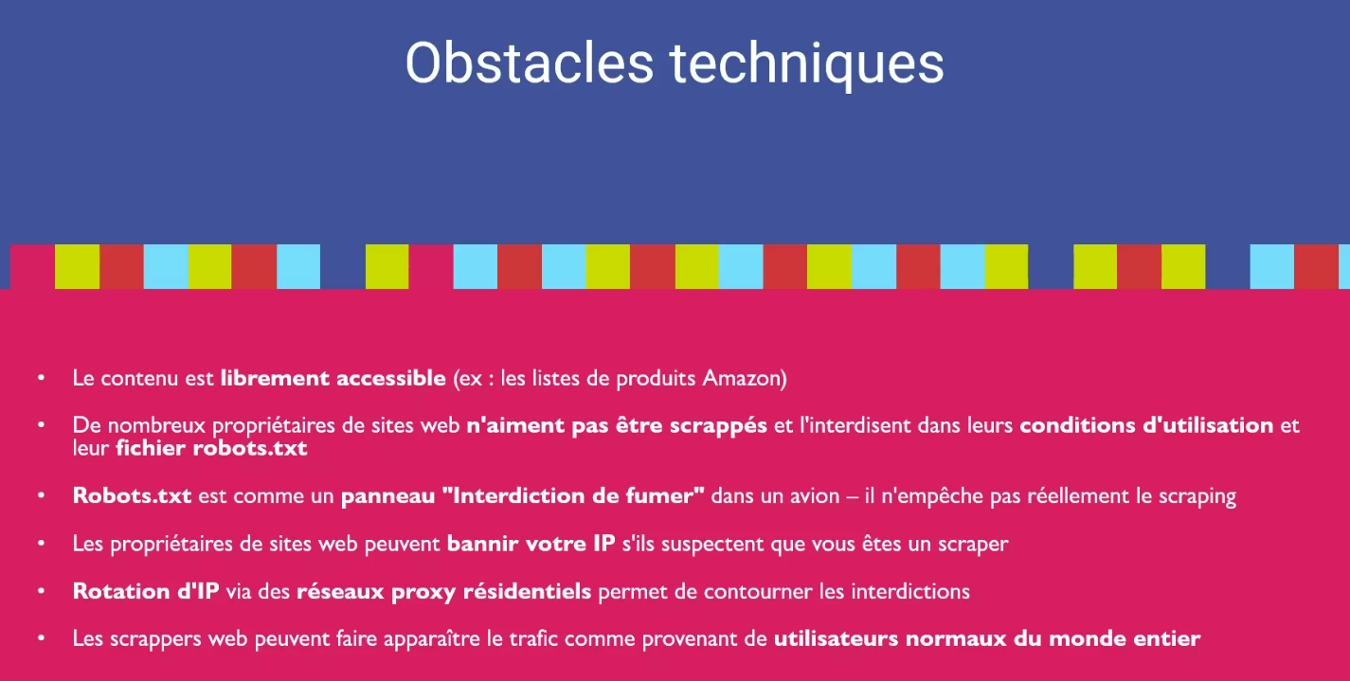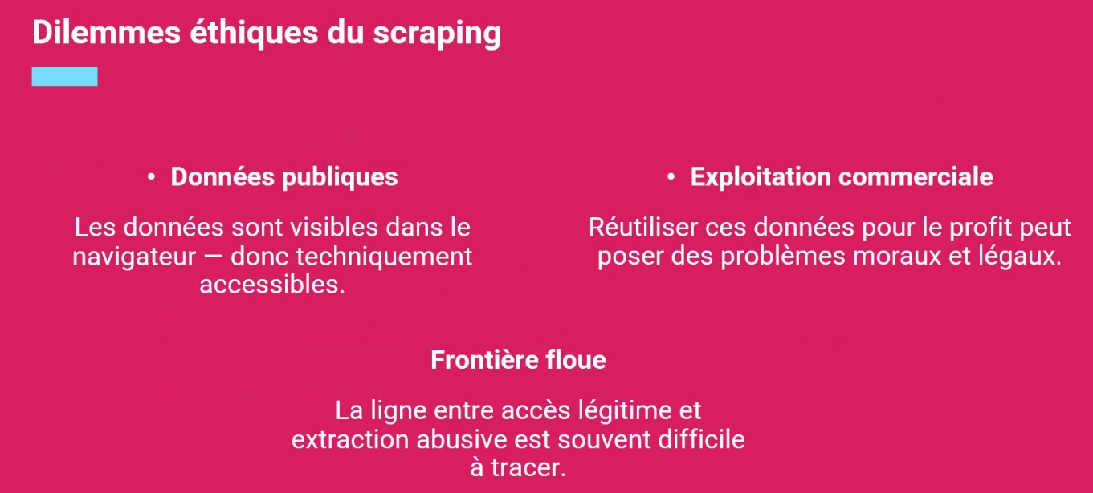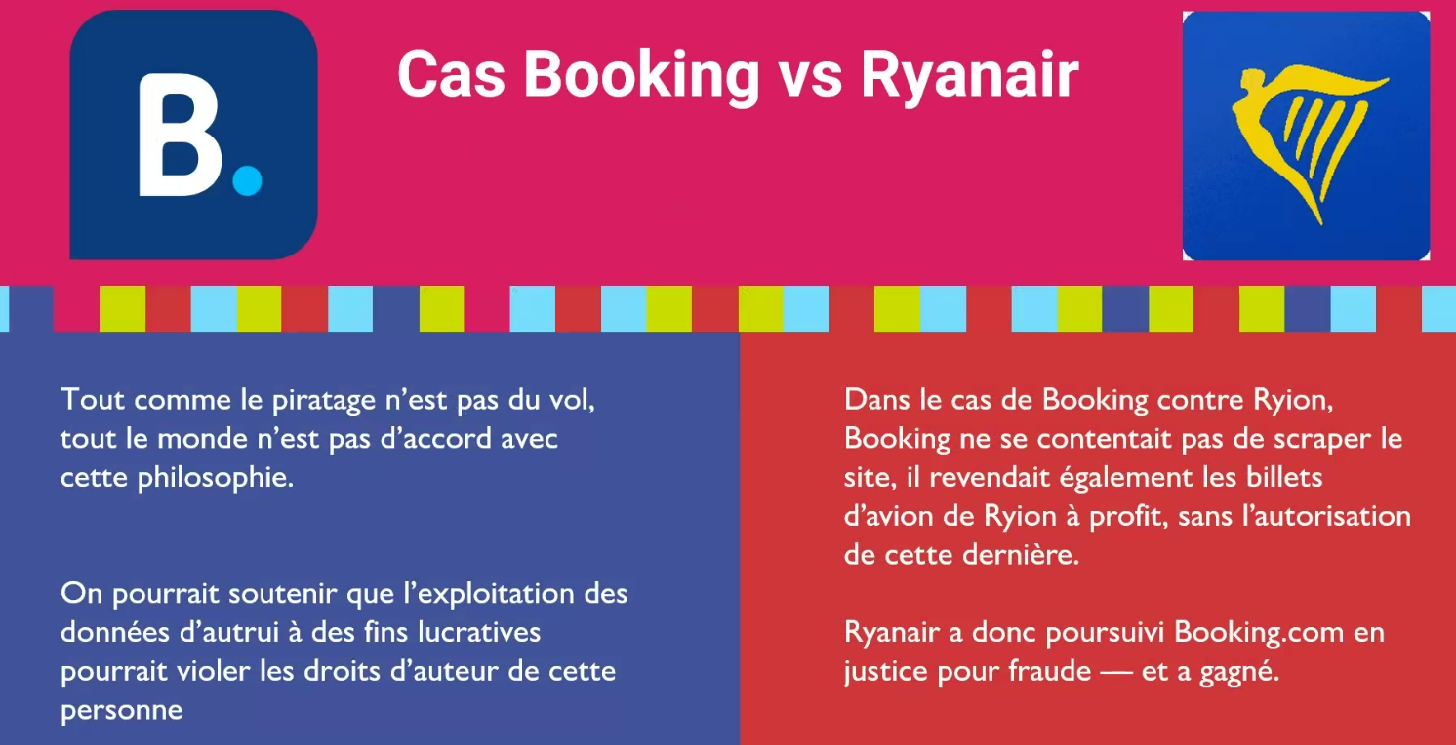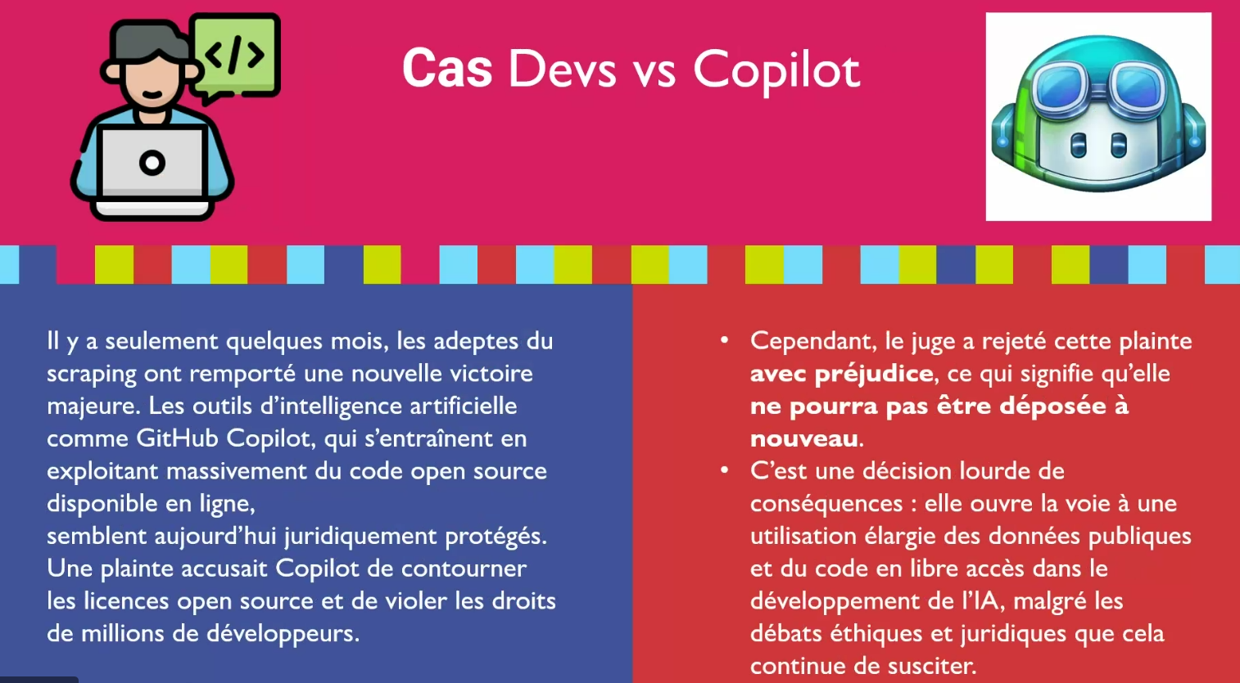

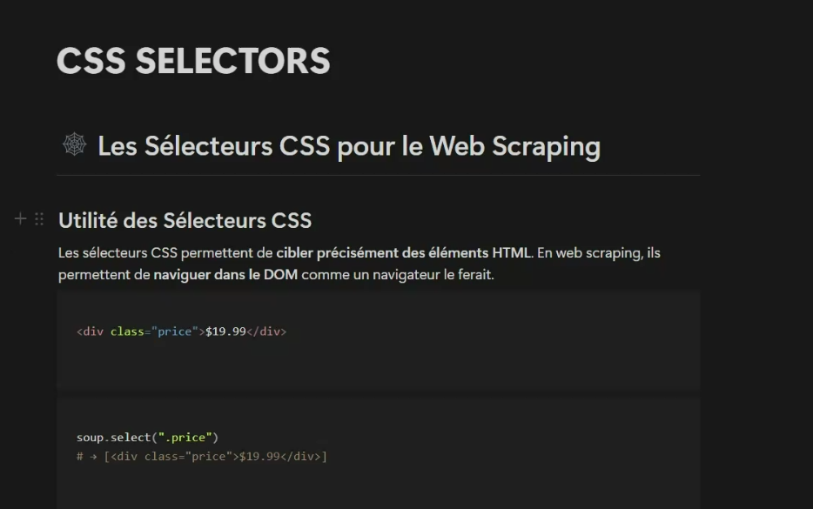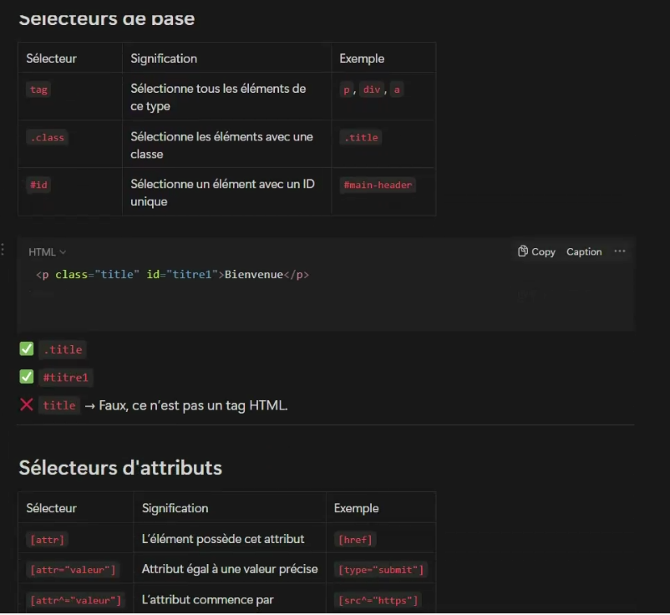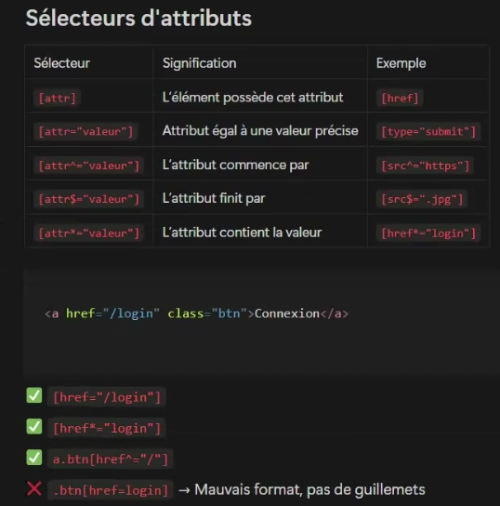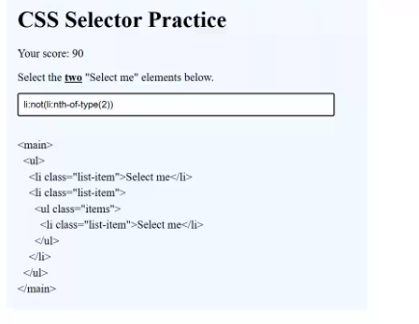

[CSS selectors - CSS | MDN](https://developer.mozilla.org/en-US/docs/Web/CSS/CSS_selectors) <https://developer.mozilla.org/en-US/docs/Web/CSS/CSS_selectors>

<https://en.wikipedia.org/wiki/Beautiful_Soup_(HTML_parser)#:~:text=Beautiful%20Soup%20is%20a%20Python,Leonard%20Richardson>

"C:\Users\Kalyan\Desktop\MscBigDataAI\IPSSI\9th W React\test.py"

